# Kenneth Mead CSI-3670-14117.202110

# Lab 7 VPN

**Questions**

1. (10 points) What do the tasklist commands do as asked on the first page?

Provides a list of memory usage for running processes

1. (15 points) Describe the counters as asked.

\SMB Server\Write Requests/sec – Provides a quick assessment of Server

Message Block protocol messages

\GPU Engine(*)\Running Time – Tracks the running GPU time for a process

\RAS\Total Clients – Contains the total number of clients connected through the

RAS VPN

1. (5 points) Answer the question about typeperf:

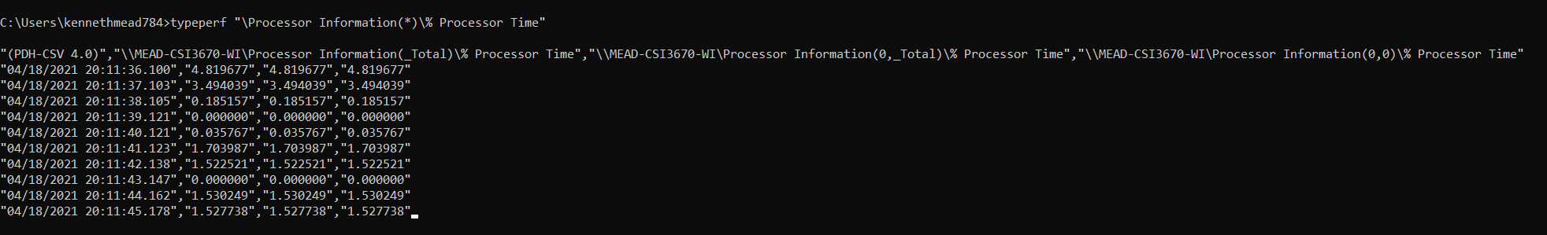

The “-sc 10” defines to only take 10 samples.

The “-si 5” defines to only take data every 5 seconds

1. (15 points) Only one real question outside of what was previously asked. What is a performance baseline and why is it necessary, and furthermore, how would you go about creating one (i.e., what you just did in the lab)? Make sure to address all three points.

A performance baseline is the process of understanding the load on a PC with its minimal needed software installed.

To create one, install all software that is expected.

1. Record information about what memory usage, processor time, etc. (program counters) there is interest in.

2. Create reports of expected performance in the performance monitor

3. Automate data collection through the performance monitor and data collection sets

1. (45 points, 5 points each) Paste all screenshots here. There should be at least 8, or 9 if you did two separate screenshots at the end of page 1.

**Screenshots**

